Chapter 15, Solution 54.

Design a problem to help other students to better understand solving second order differential equations with a time varying input.

Although there are many ways to solve this problem, this is an example based on the same kind of problem asked in the third edition.

Problem

Using Laplace transform, solve the following differential equation for t >0

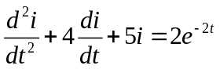

subject to i(0)=0, i’(0)=2.

Solution

Taking the Laplace transform of each term gives

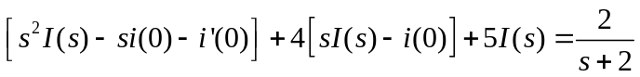
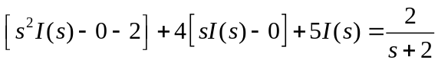

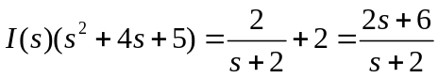
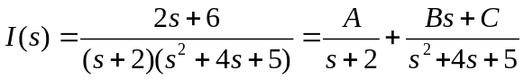

We equate the coefficients.

s² : 0 = A+ B
s: 2= 4A + 2B + C
constant: 6 = 5A + 2C

Solving these gives
A = 2, B= -2, C = -2

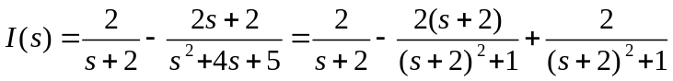

Taking the inverse Laplace transform leads to:

